- We get manifest as an.xlsx from Valley/BYD email with order info and an expected date of arrival in the body of the email.
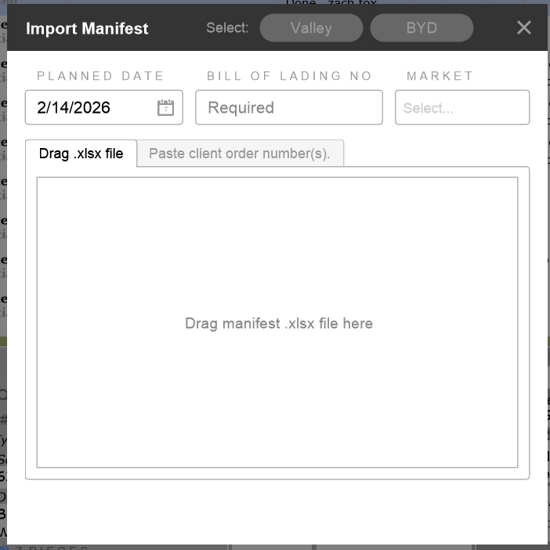
- We run the import script-- EDI- import BYD/Valley manifest. Drag/drop the manifest into the tool The date will be in the body of the email, BOL # is in the subject line of the email, choose market. If there are multiple markets, the EDI will import all with no issues. (can we use this tool for ALL customers if we can extract the relevant information from other customers PDFs?)

- Jobs will automatically be scheduled on the ‘Planed Date’ from the tool. The is the date that BYD chose as an expected arrival date to our dock.
- When the BYD truck arrives, the WH or Ops team scan the items in. Clicking the wrench/screwdriver tool in FM (bottom of the screen) opens a screen that tells the status of the delivery from BYD or Valley.
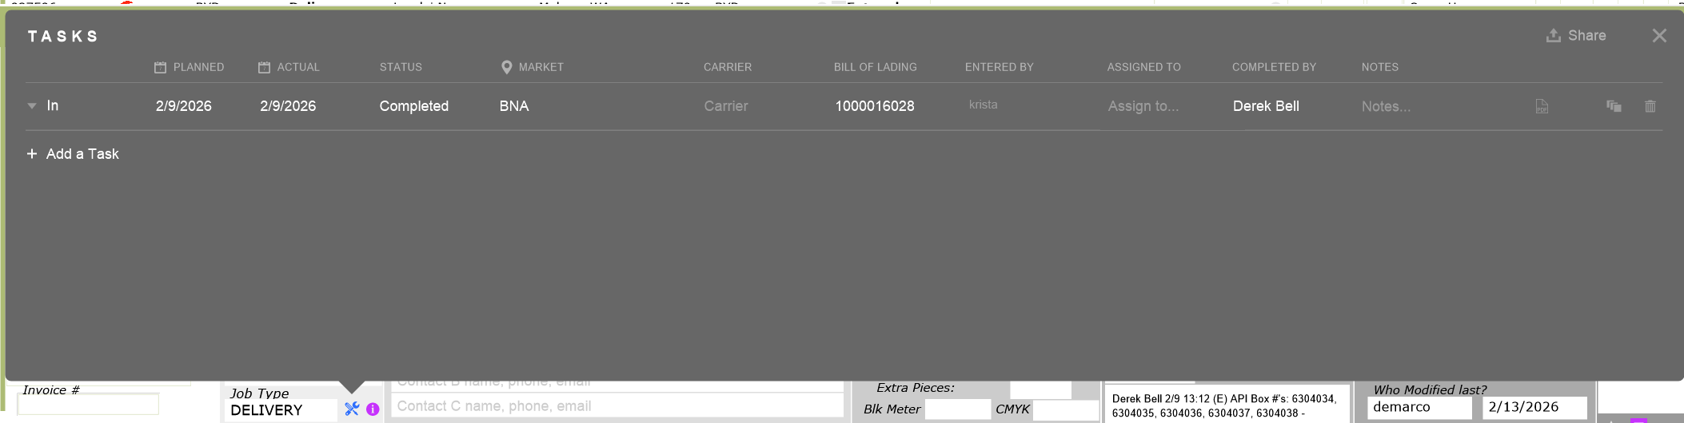
This will give the planned date, and if the WH or Ops team has scanned, there will be an actual date along with info from the initial import.
- Once the delivery is confirmed with the scan, the Ops manger will then route it. It is unknown how often/when/how they verify statuses of the BYD deliveries. Also the philosophy priorities in how these are scheduled is not the same between Ops managers. Some schedule the BYD/Valley and work their schedule around it, some route their schedule and fit BYD/Valley in where it makes sense for a particular route or date.

- After it is routed, it will show up in the pre-call screen for the CSR’s. If the delivery is a drop and go we send a pre-formatted text message or e-mail (shown below) letting the customer know when it is scheduled. If the delivery is a white glove, or threshold the CSRs call to confirm date/time with the customer as they need to be there to sign.

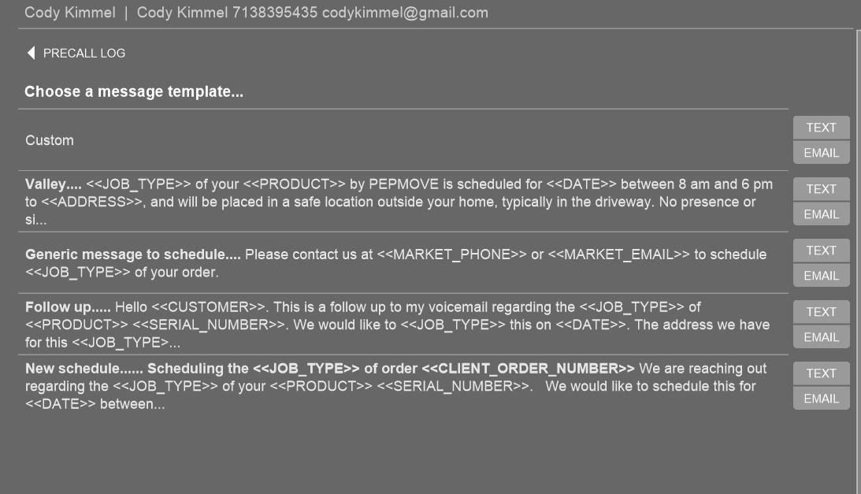
- The customer will call e-mail if our suggested date does not work. Dual Sync SMS is not currently an option in our FM. We do not have a consistent process in what happens when a customer does not respond; this is true for drop and goes and signature required deliveries.
- While confirming, white glove deliveries sometimes have very specific requests eg: In gras by the driveway, in the back yard, right side of garage etc. We put this request in the notes but it is not always visible to the driver on the paperwork. Also, we do not have a current script asking if there are dogs, uneven ground (large rocks, obstructions) issues, narrow gateways, fragile objects near the drop site.
- If the job is rescheduled, CSRs need to
- Ask ops for good day/time to reschedule. Once this is done..
- Unassign drivers
- Remove Route info
- Update the date to move call
- **Email BYD/Valley about the moved call. Liz is the only person doing this right now, and we will make it the standard.
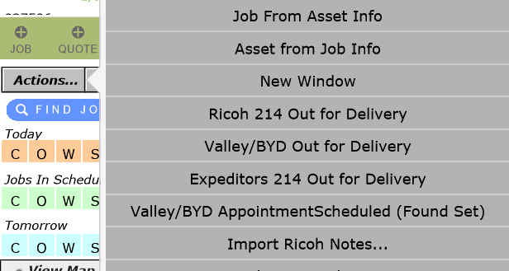
- On the morning of delivery, a CSR sends OFD via the Action tool Valley/BYD Out for Delivery to send 214 with info

- Driver makes call when 30-60 minutes away within the window (if white glove or threshold) and delivers.
- Once drive has entered their in/out times, pictures and changes the status to a complete status, another update is sent to BYD/Valley confirming the delivery was made.

Besides the issues noted above, we need to resolve these issues
- Sometimes, a client says that have were told a specific time/date by Valley/BYD before we even get the manifest. This causes confusion, frustration.
- Valley deliveries are often late, it is not known how Ops are tracking this and following up. Most recent delivery was 10 days after the date given by Valley.

